Problem-3

**SYED GHASSAN FAHEEM**

**15l-4375**

**Section B**

**Digital image processing**

STEPS FOR SOLUTION:

1. Vector X is obtained by reading data.m file which contain all training data of images.
2. Co-Variance of the training data is needed for which we need to center the data by removing the mean from the image and then calculate the unbiased covariance of R as follows:  
     
   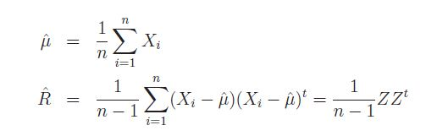

1. We have an estimation of co-variance but Note that if ˆR is not full rank, some of the eigenvalues in lamda will be zero.
2. We then use the SVD command of Matlab which returns the USV where U and V are othonormal columns and S

U is pxn and left singular vectors  
S is nxn and singular values  
V is nxn and right singular vectors

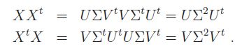

1. Since S^2 is diagonal, both equations are each in the of an eigen-expansion. So from the SVD of the data matrix X, we see in top equation that the left singular vectors in U are the n eigenvectors of XXt corresponding to nonzero eigenvalues, and the singular values in S are the square roots of the corresponding eigenvalues. Now since ˆR = (1/n)XXt, the result in (22) allows the calculation of the non-zero eigenvalues and corresponding eigenvectors of ˆR without explicitly computing ˆR itself, which is especially efficient if n << p.
2. If we let U base m be a matrix containing the first m eigenvectors, Um = [u1 · · · um], the eigenvector feature vector, Y in my case Ytemp , for the image X is computed by



1. Note that Y is not an image–it doesn’t even have the same dimension as X. However, we can obtain an approximation of the original image X from a linear combination of the eigen images.

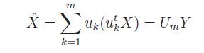

1. Use of the approximation is commonly referred to as principal component analysis, or PCA.

Below attached are the required Images

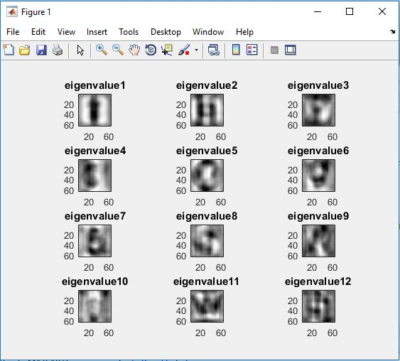  
  
Figure 1 (First 12 eigenimages)

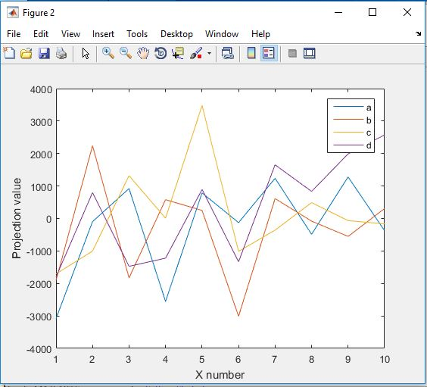

Figure 2 (Projection coefficients vs. eigenvector numbers)

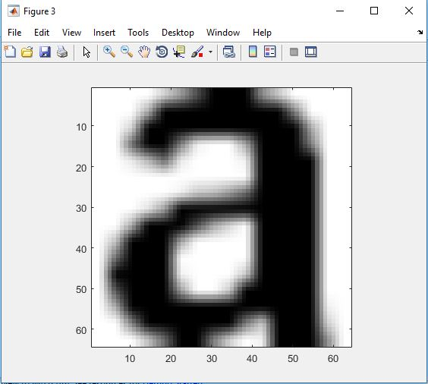  
 Figure 3 (Original image of a)

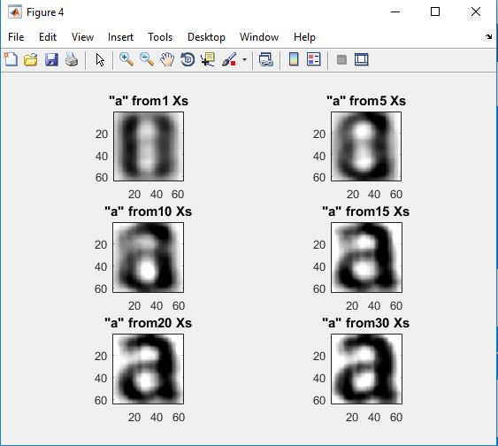

Figure 4 (Resynthesized versions of a )

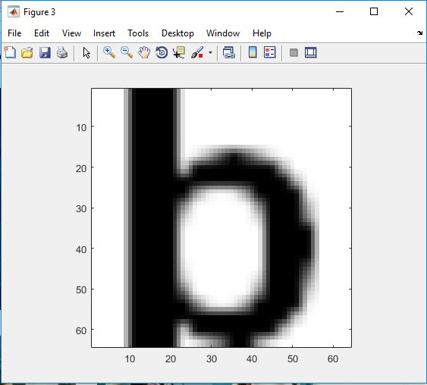

Figure 5 (Original image of b)

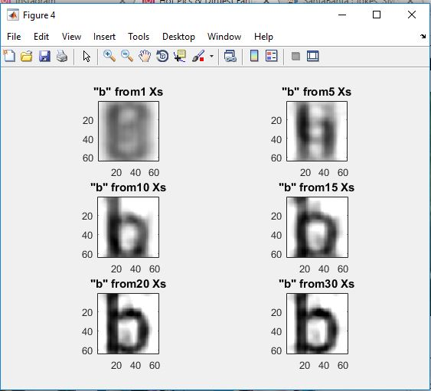

Figure 6 (Resynthesized versions of b)

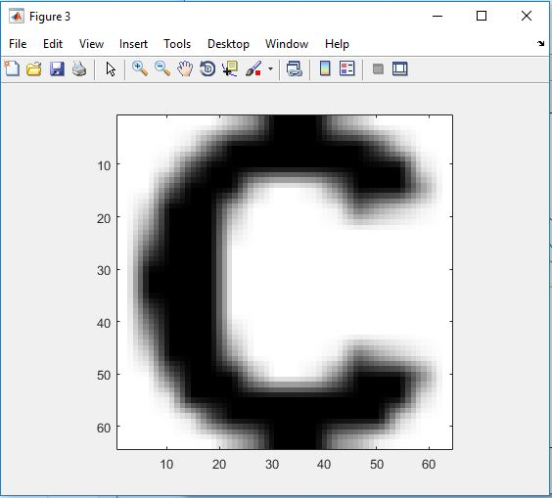

Figure 7 (Original Image of C)

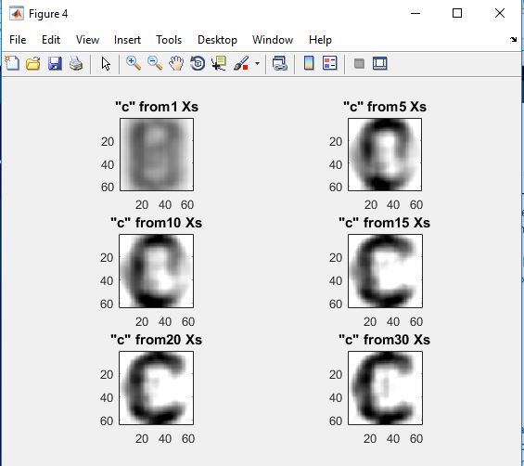

Figure 8 (Resynthesized versions of c)

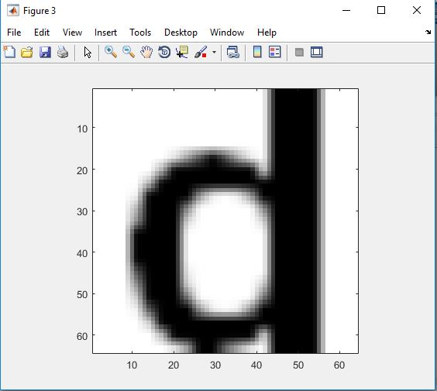

Figure 9 (Original Image of d)

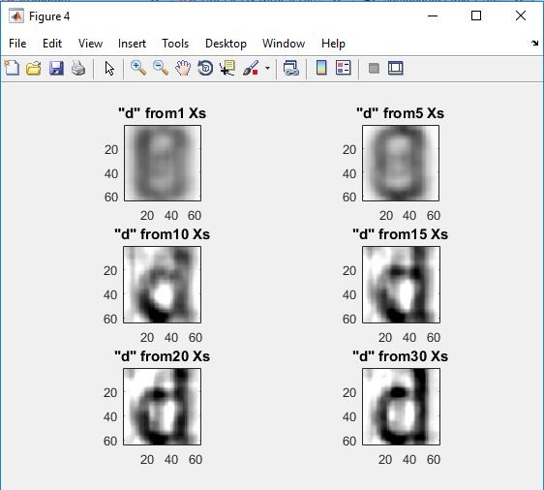

Figure 10 (Resynthesized versions of d)